MY PORTFOLIO



Chinasa Elukposi, known as The Seasoned Book Editor, is a professional book editor, ghostwriter, author, book writing consultant, and writing coach. She works with writers who desire more than completed manuscripts. She helps them achieve clarity, structure, and lasting impact.

She holds a degree in Applied Biochemistry from Nnamdi Azikiwe University. Her academic background trained her in discipline, precision, and critical thinking, qualities that strongly influence her editing and writing process.

Over time, she has helped many authors turn their manuscripts into life-changing global books. She has also supported busy authors by converting recorded audio content into clear, well-structured ebooks. Her keen eye for detail and strong commitment to delivering clean, error-free material allow her to bring book ideas to life without losing the author’s voice.

She serves as a student aide and the lead trainer at Seasoned Writers Academy, where she grooms aspiring and intermediate writers to write beyond words. Her work focuses on structure, clarity, purpose, and consistency, helping writers grow in confidence and skill.

As a passionate educator and administrator, she has worked as a private teacher, helping examination candidates prepare thoroughly and perform excellently. She also volunteered with EduFest Africa, an educational program organized by Springsgates Grammar School. In 2024, she was recognized as one of the outstanding volunteers, an experience that strengthened her interest in education and event coordination.

She is the Grand Coordinator of Smart Students Global Academy, where she leads an examination body dedicated to equipping students with the skills, knowledge, and confidence needed to succeed academically and beyond.

Chinasa Elukposi is the author of two books, The Drive and Upgrade to Explore, with more projects in progress. Her writing reflects growth, intentional living, and disciplined personal development.

Above all, she is a lover of God and a young lady deeply committed to helping young people discover their purpose, build capacity, and walk confidently in the direction of their calling.

Key Skills
- Structural / Line Editing.
- Copyediting / Proofreading.
- Strong command of grammar, punctuation, and sentence structure.
- Content writing and manuscript development.
- Audio-to-ebook conversion.
- Attention to detail.
- Strong understanding of context, tone, and messaging.
- Effective time management and deadline control.
- Clear, consistent communication throughout projects.
- Respect for author's voice and creative intent.
- Manuscript preparation for publication readiness.

Brand Vision: To help authors shape their ideas and manuscripts into published life-changing global books.

Brand Mission: To work closely with authors, brands, and individuals to refine ideas, strengthen manuscripts, and guide each project through a clear, disciplined process that results in well-structured, high-quality books prepared for global publication.

MY CERTIFICATIONS

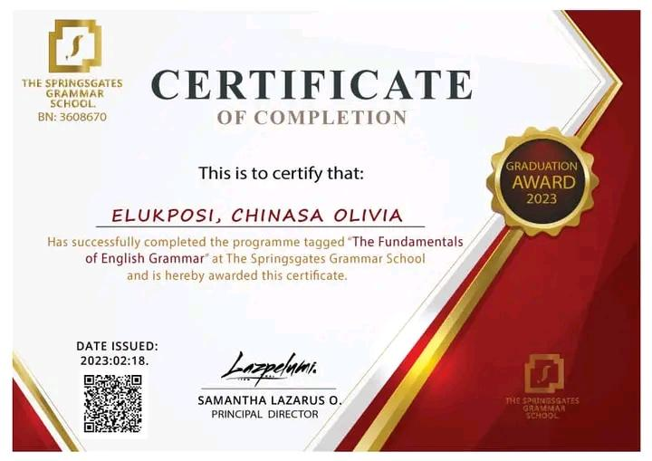
Certificate: Fundamentals of English Grammar
Issued by: Springsgates Grammar School
Date: 18th February, 2022

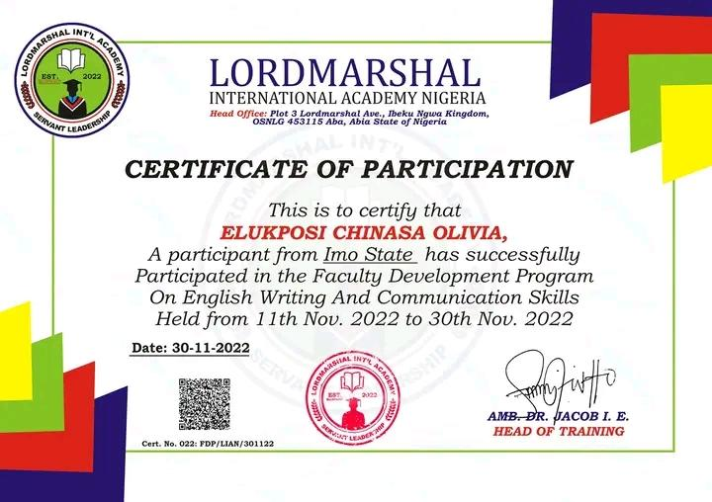

Certificate: English Writing and Communication Skills
Issued by: LordMarshal International Academy, Nigeria
Date: 30th November, 2022

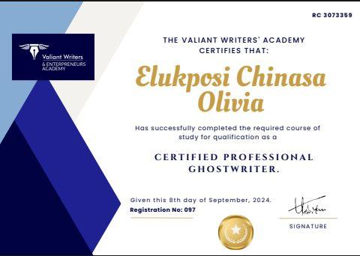
Certificate: Professional Ghostwriting
Issued by: Valiant Writers and Entrepreneurs Academy
Date: 8th September, 2024

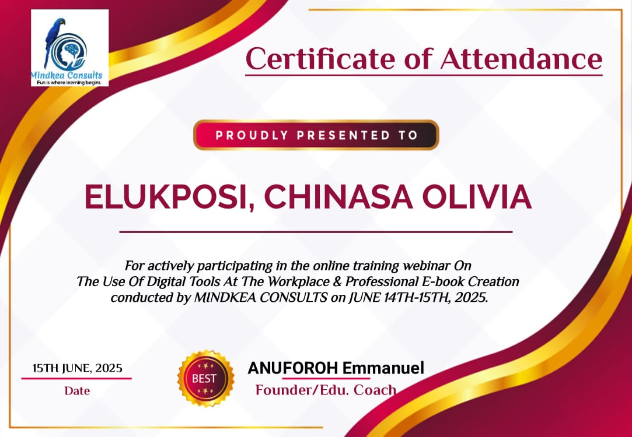
Certificate: The Use of Digital Tools At The Workplace and Professional E-book Creation
Issued by: Mindset Consults
Date: 14th-15th June, 2025

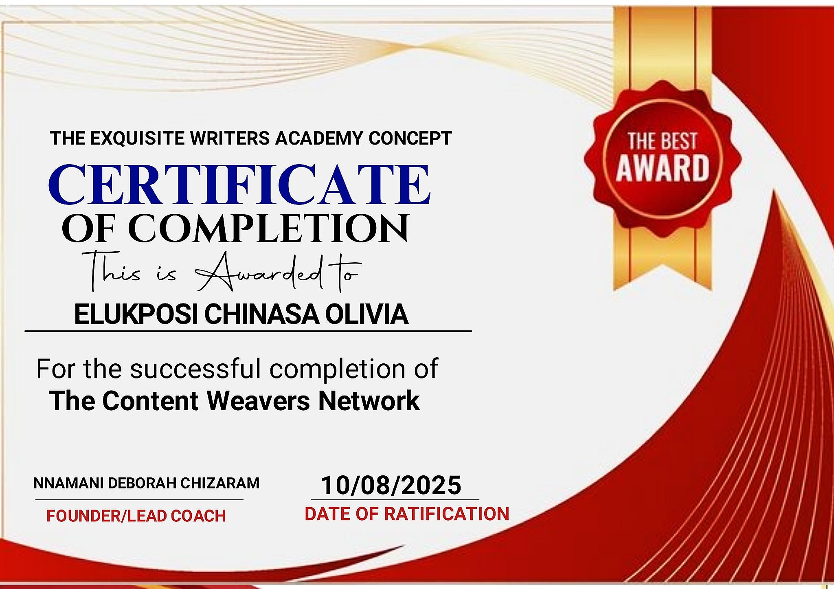
Certificate: Content Weaving/Writing
Issued by: The Exquisite Writers Academy Concept
Date: 10th August, 2025

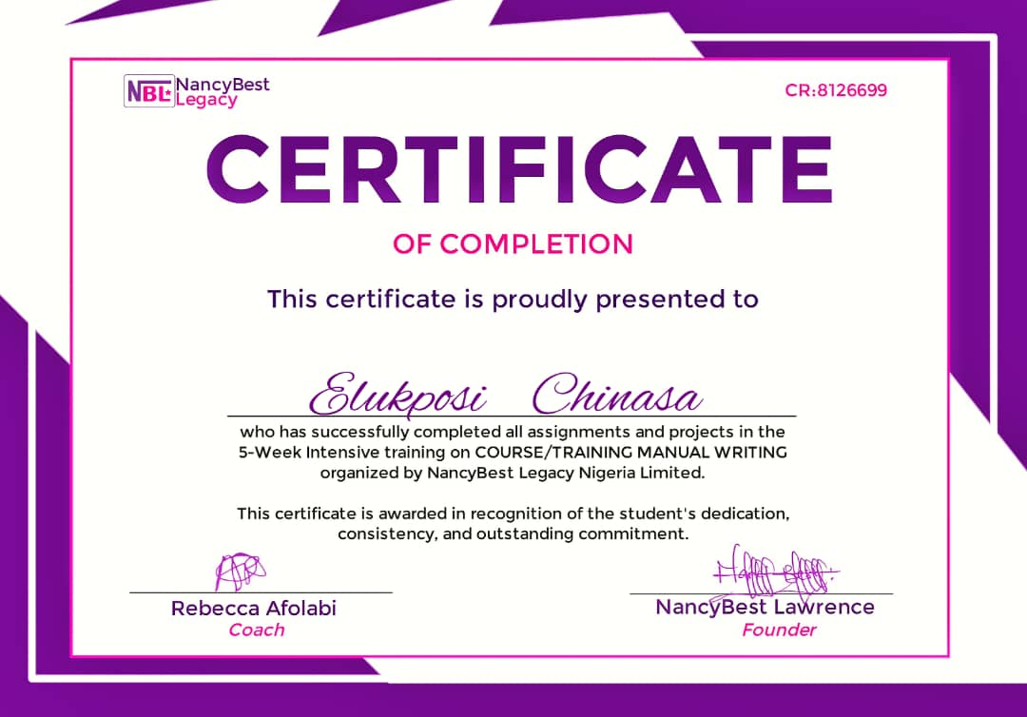
Certificate: Course/Training Manual Writing
Issued by: NancyBest Legacy Nigeria Limited
Date: 4th December, 2025

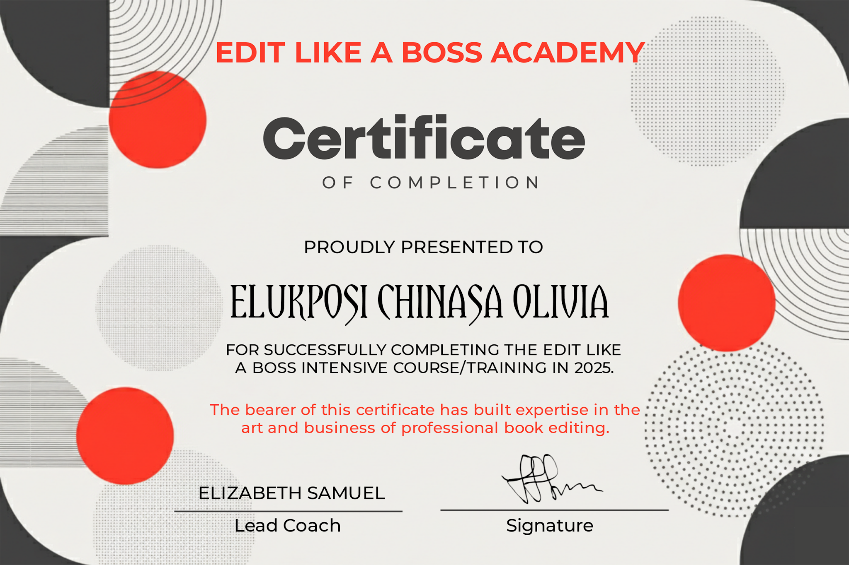
Certificate: Professional Book Editing
Issued by: Edit Like A Boss Academy
Date: 25th February, 2026

MY STUDENTS’ CERTIFICATIONS

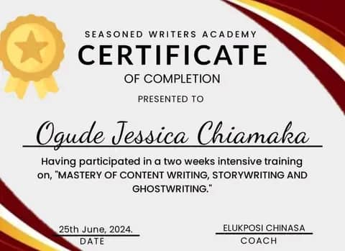

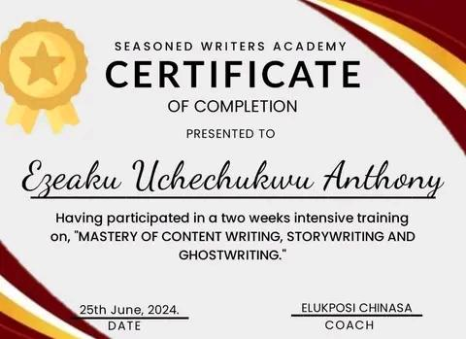

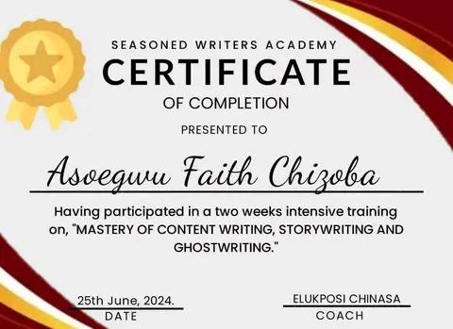

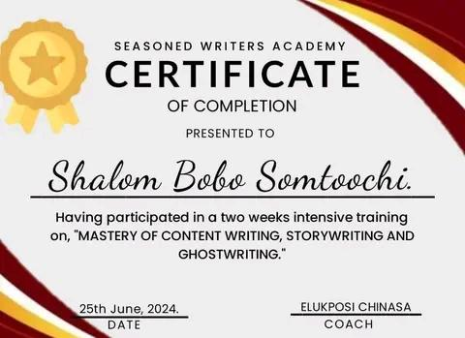

Certificate: Mastery of Content Writing, Storywriting, and Ghostwriting
Issued by: Seasoned Writers Academy
Date: 25th June, 2024

MY BOOKS

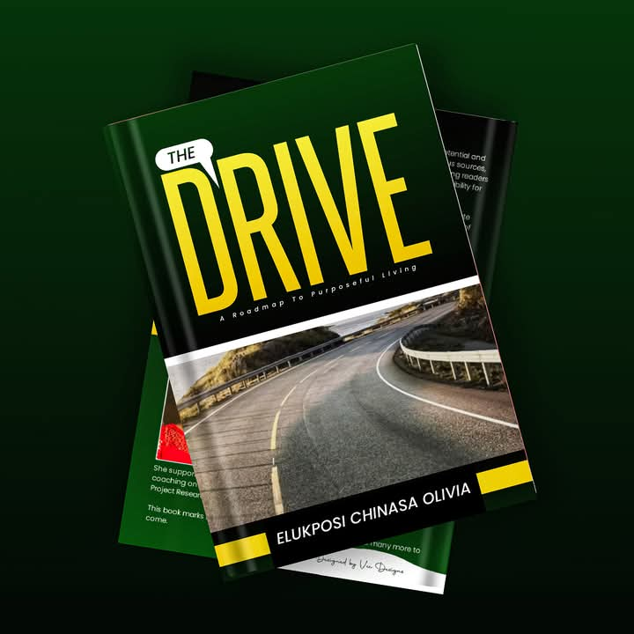
Book title: The Drive
Author: Chinasa Elukposi

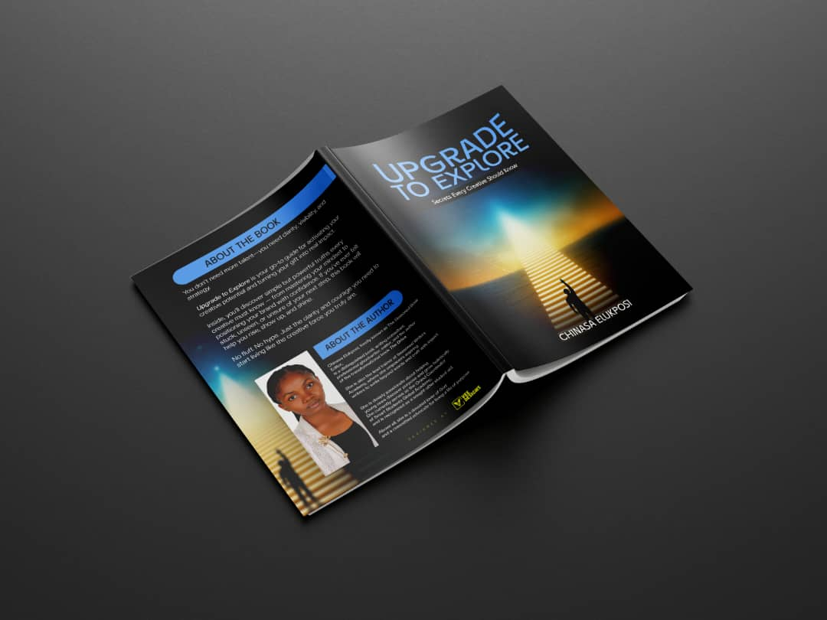
Book title: Upgrade To Explore
Author: Chinasa Elukposi

COURSE AND TRAINING MANUAL

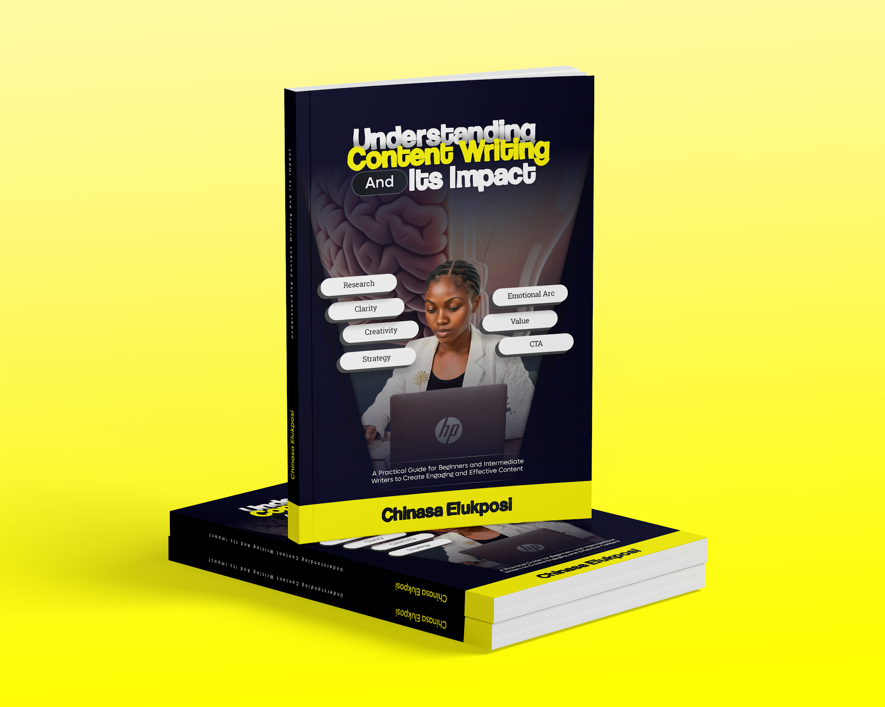
Course Title: Understanding Content Writing and Its Impact
Manual Writer: Chinasa Elukposi
Date Issued: December, 2025

SOME BOOKS I HAVE WORKED ON

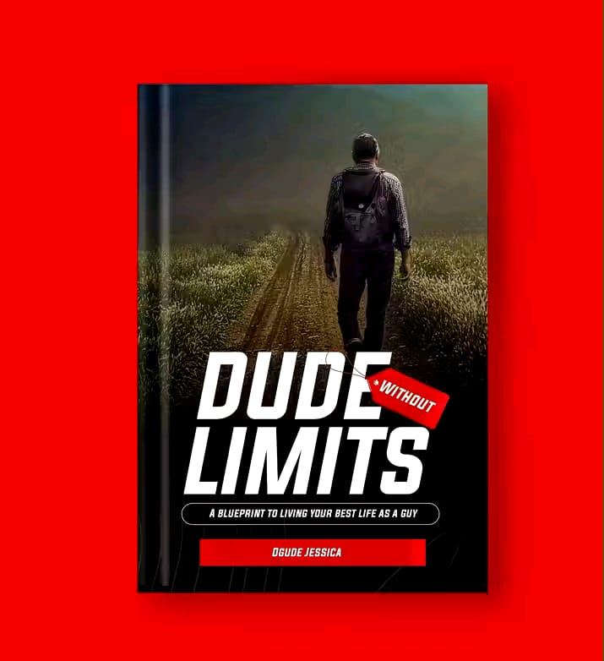
Book title: Dude Without Limits
Author: Ogude Jessica

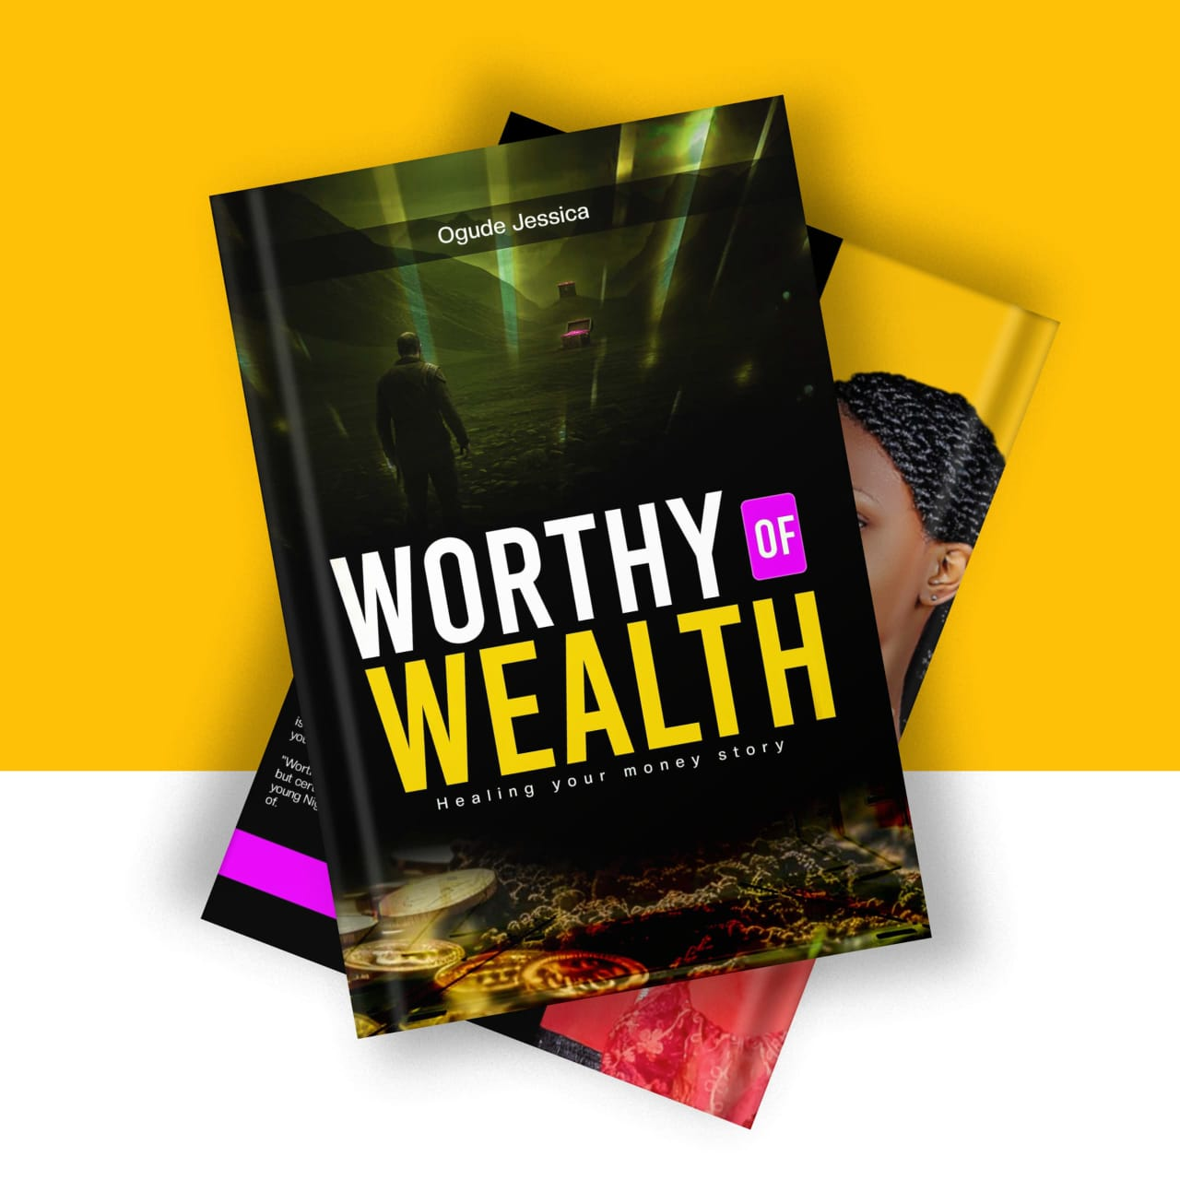
Book title: Worthy of Wealth
Author: Ogude Jessica

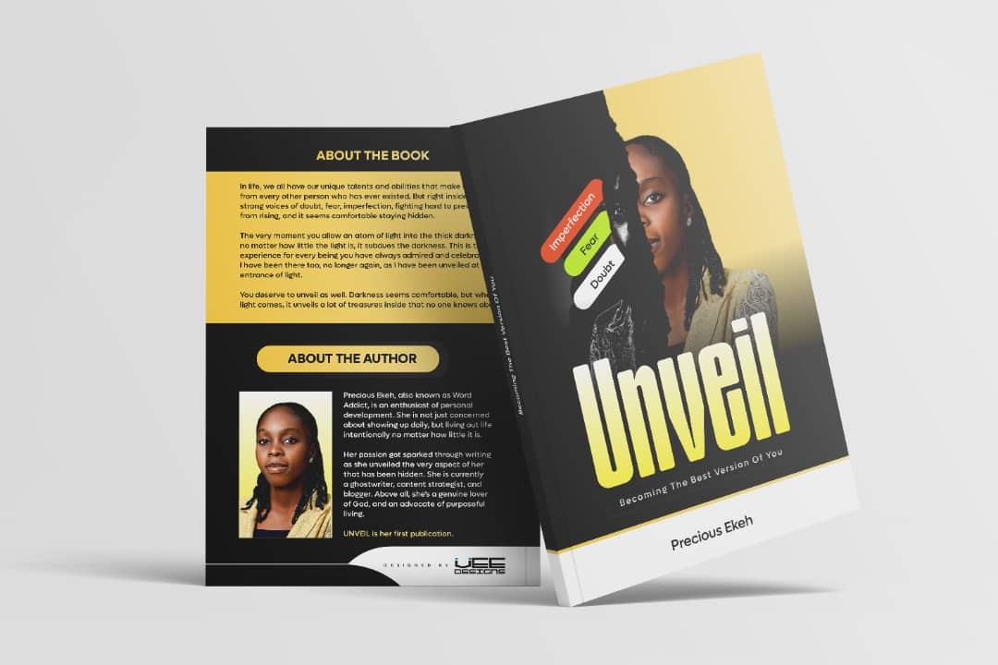
Book title: Unveil
Author: Precious Ekeh

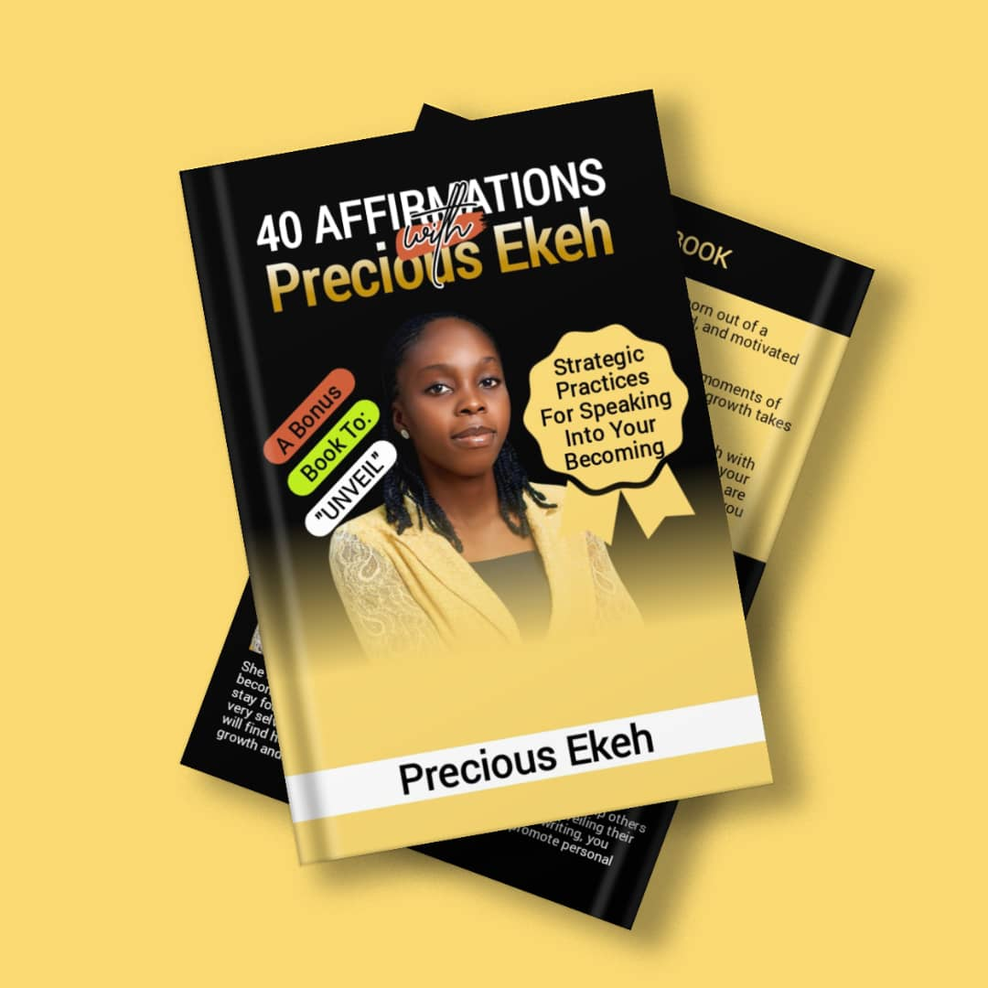
Book title: 40 Affirmations With Precious Ekeh
Author: Precious Ekeh

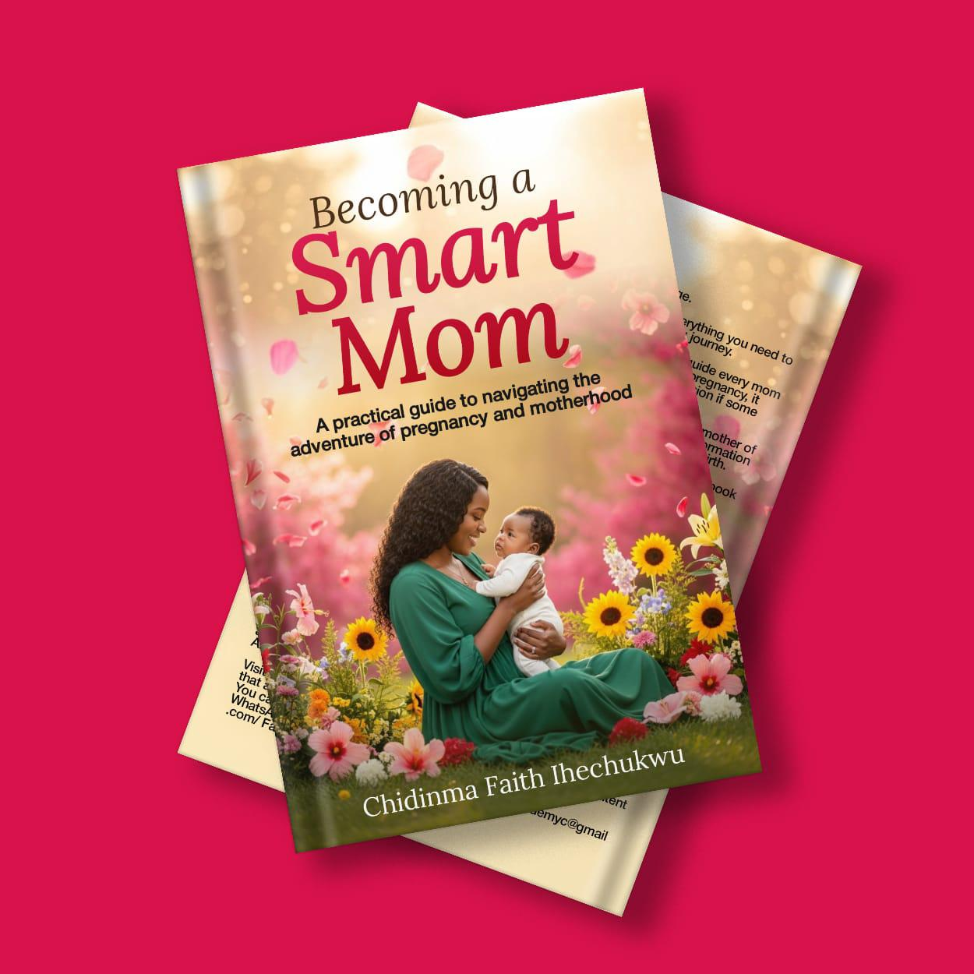
Book title: Becoming A Smart Mom
Author: Chidinma Faith Ihechukwu

MY EDITING SAMPLES

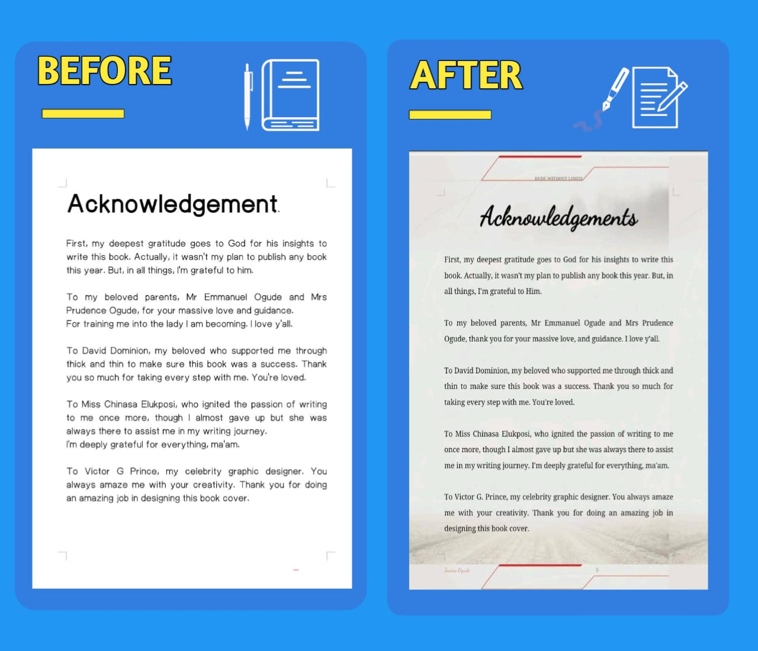
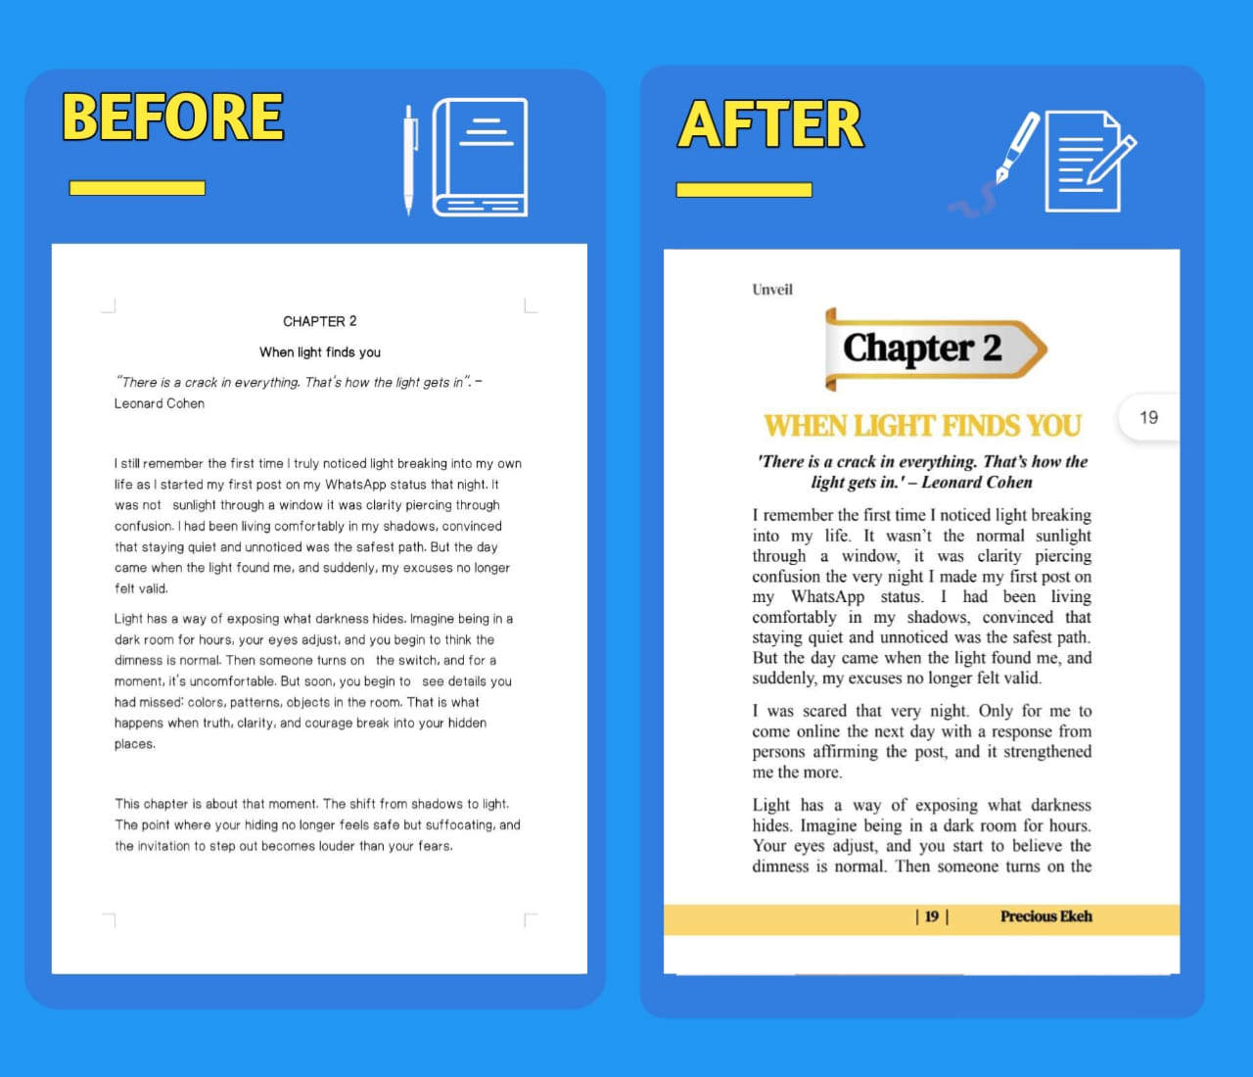
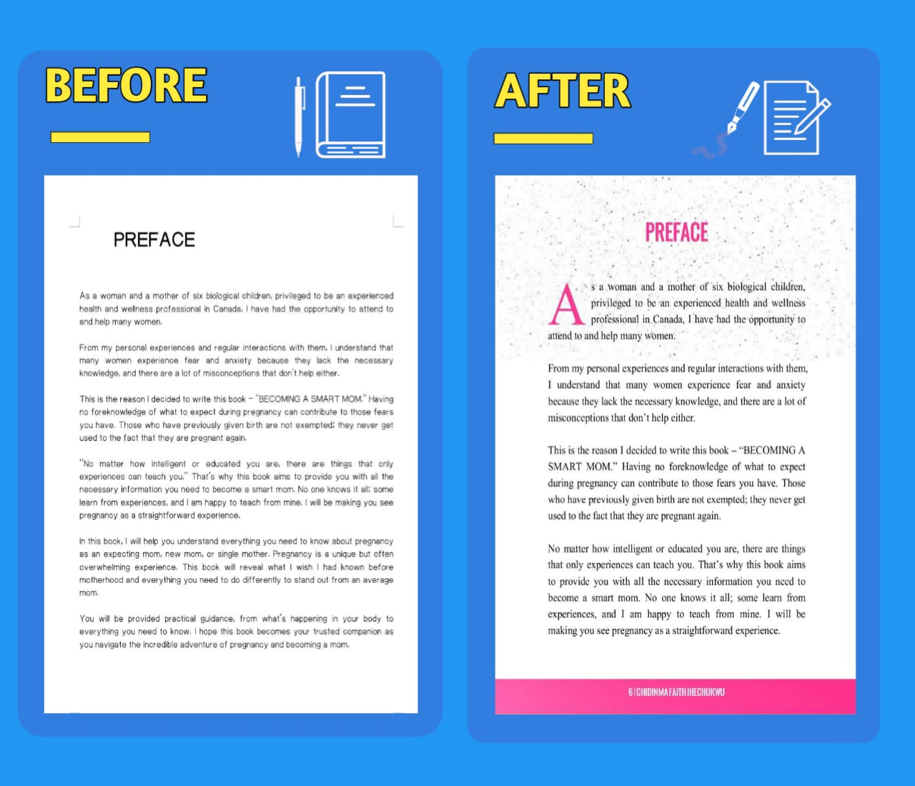

ON-BOARDING CLIENTS

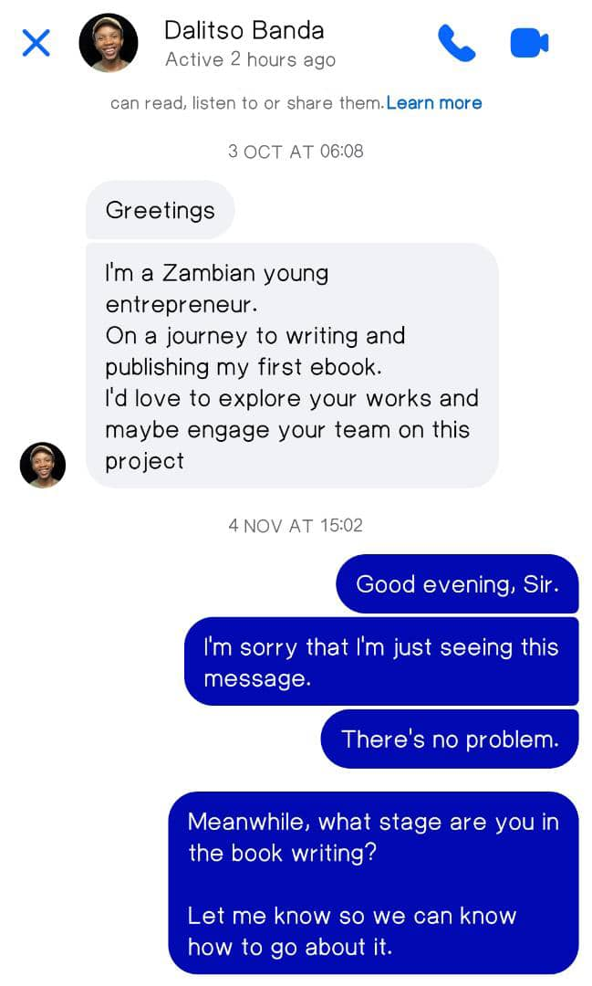
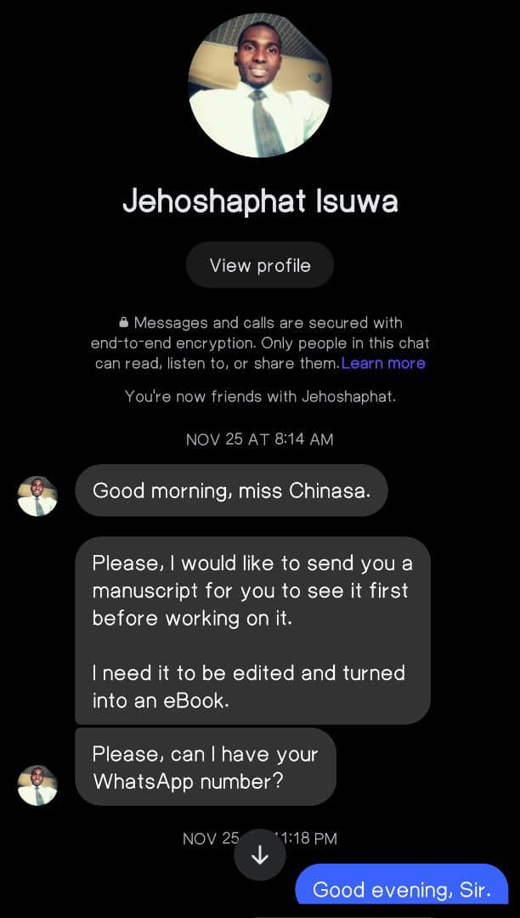

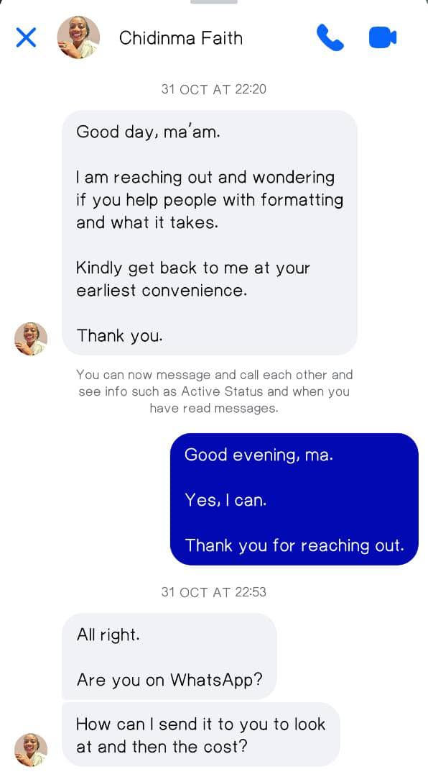

WHAT MY CLIENTS ARE SAYING ABOUT ME



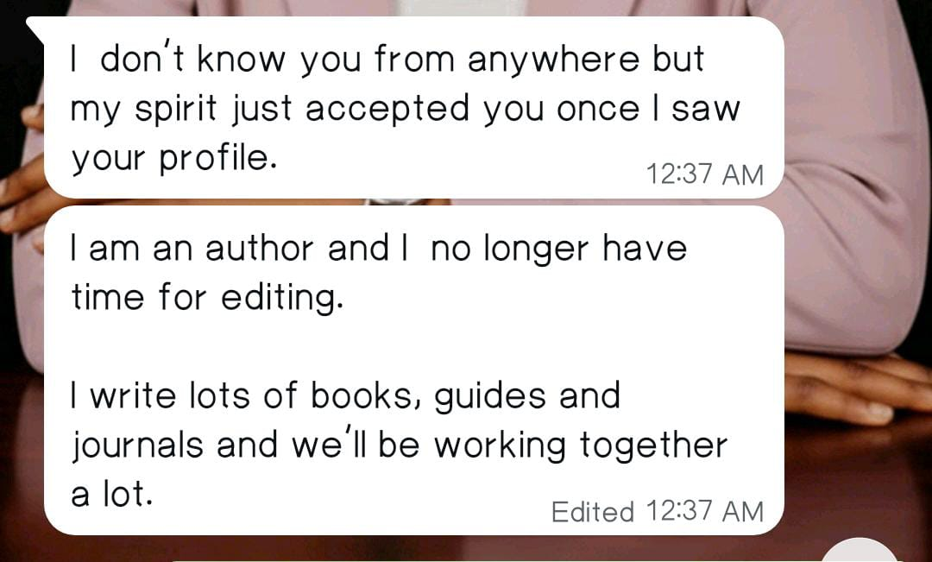

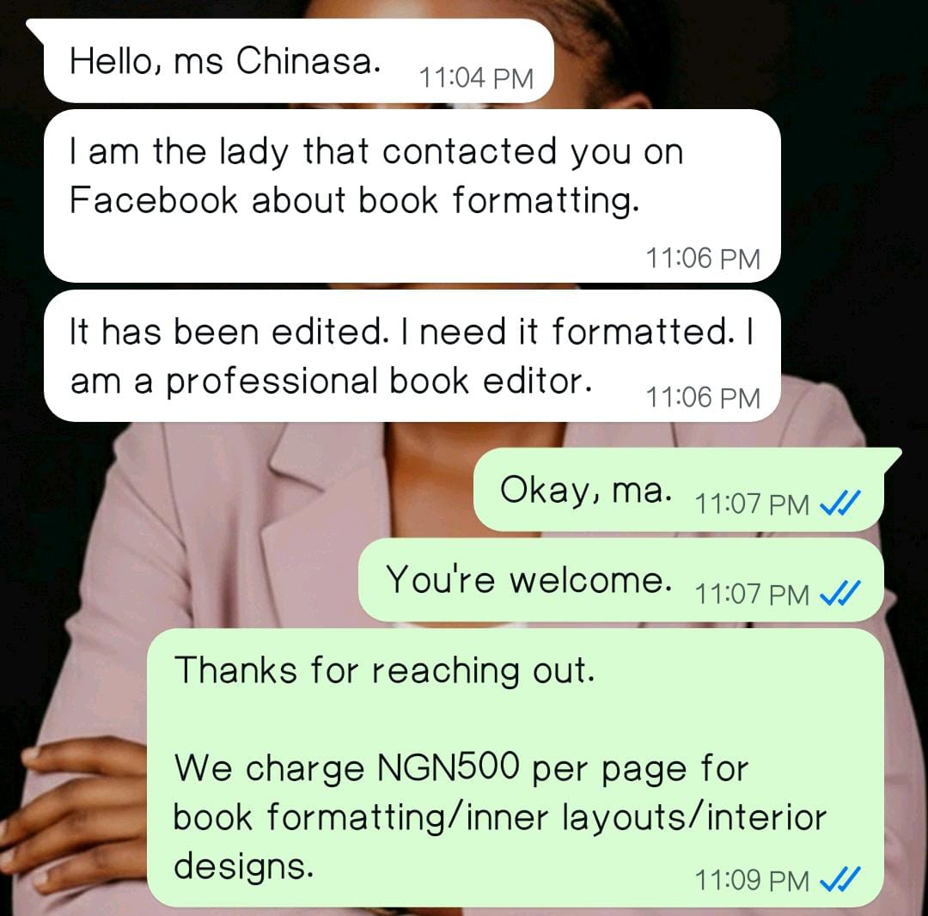

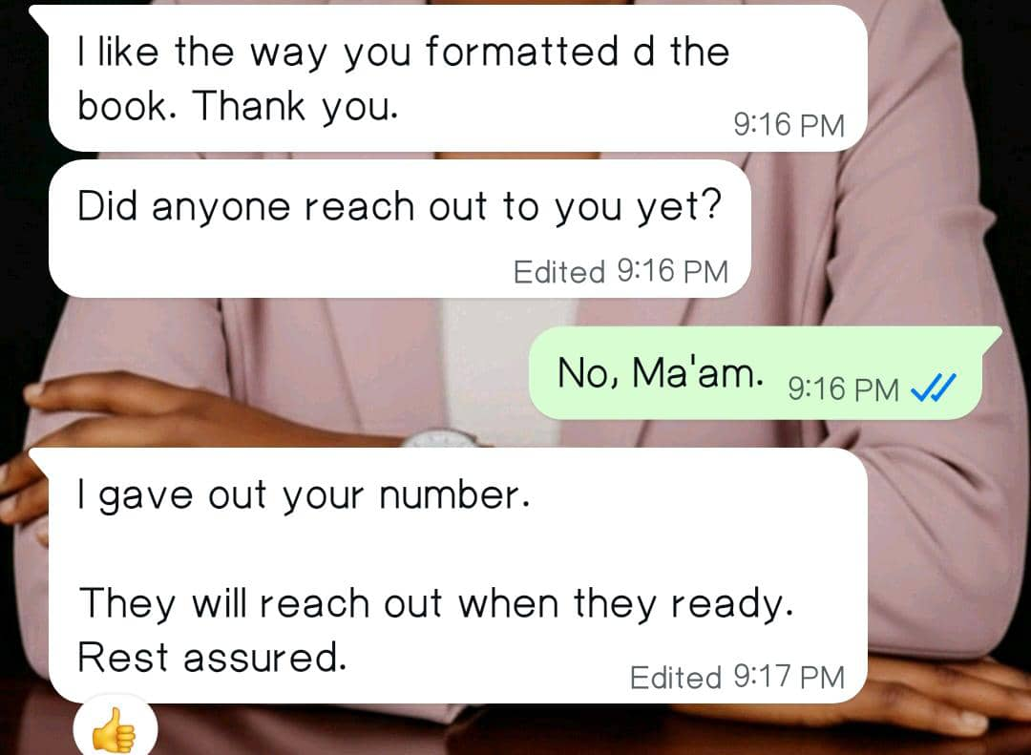

TESTIMONIALS FROM MY CLIENTS

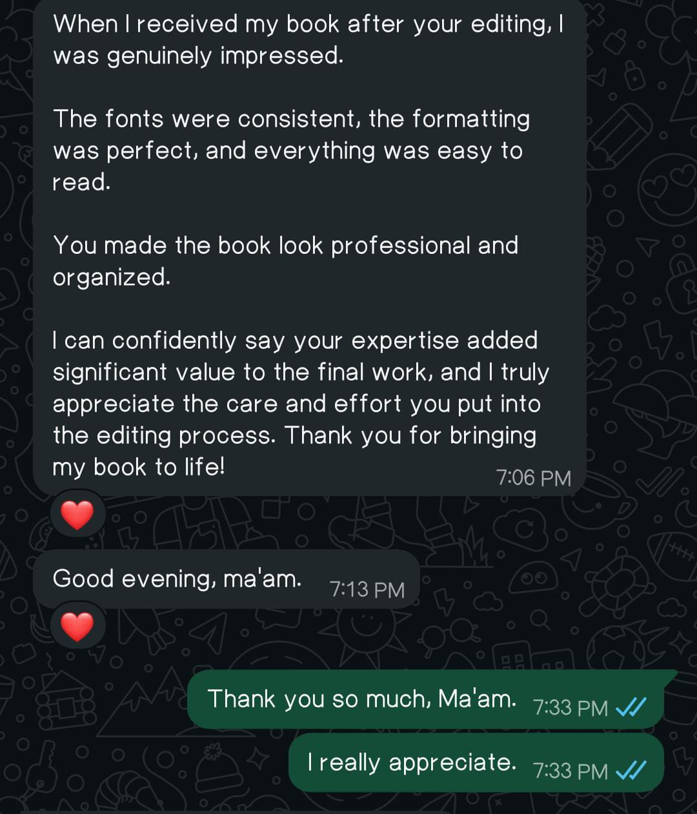

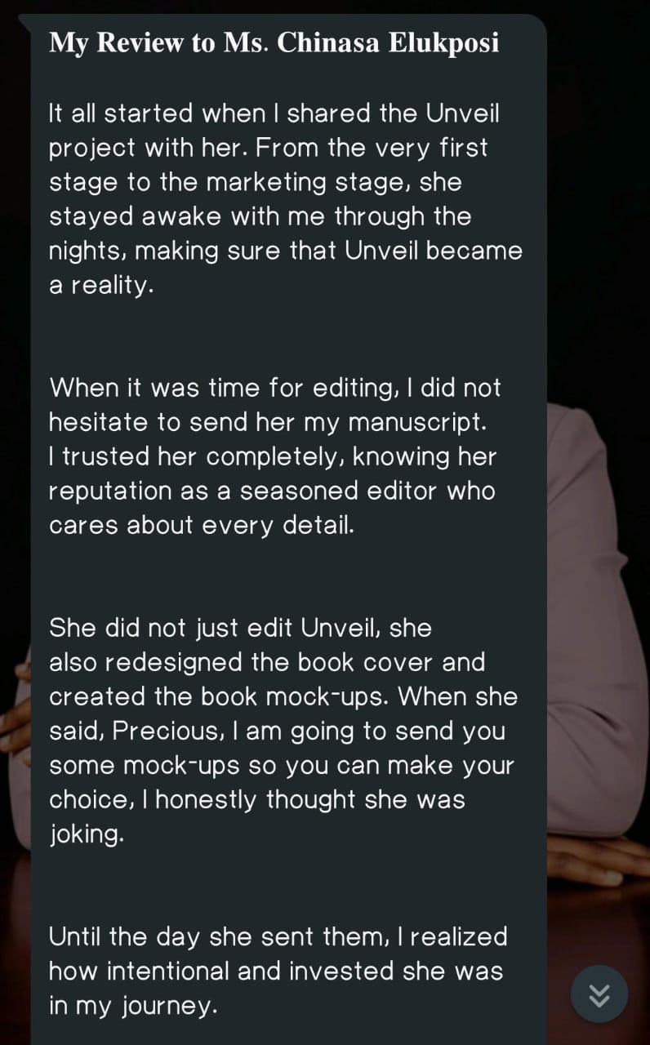

AWARD AND RECOGNITION

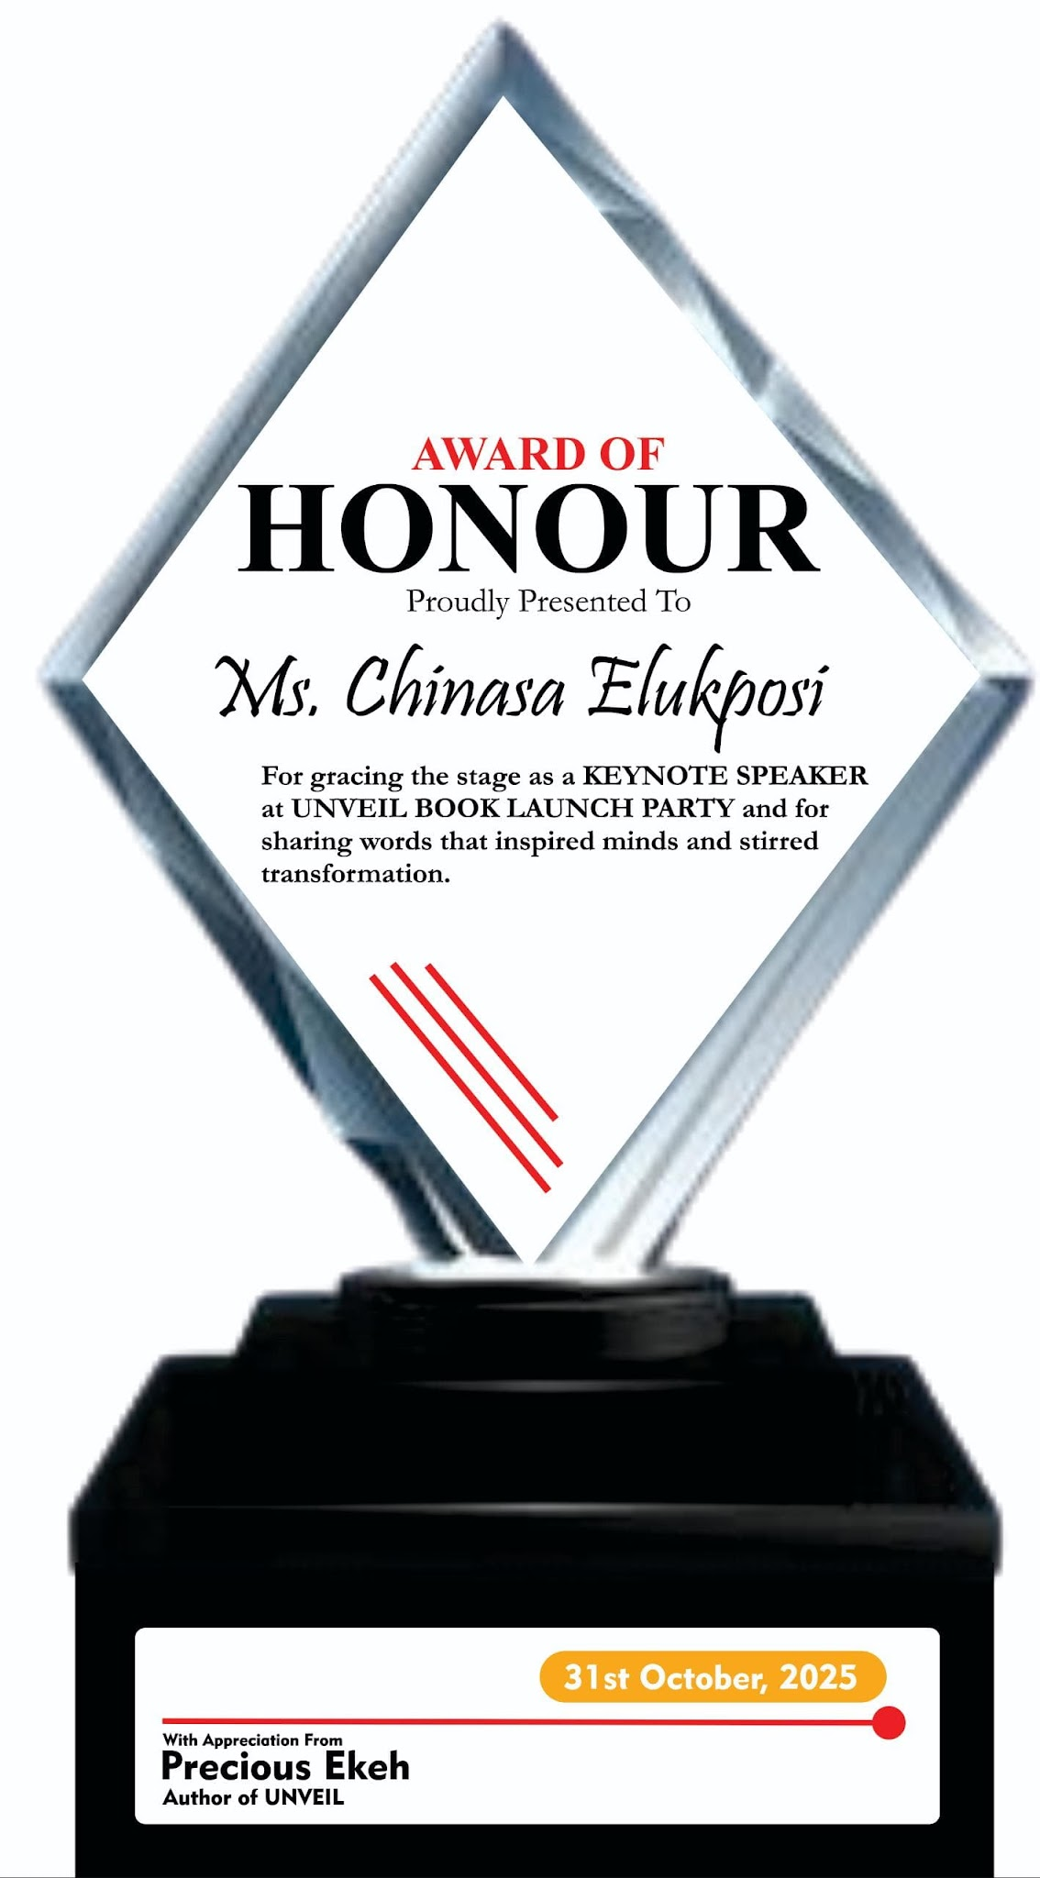

MY BUSINESS CARD

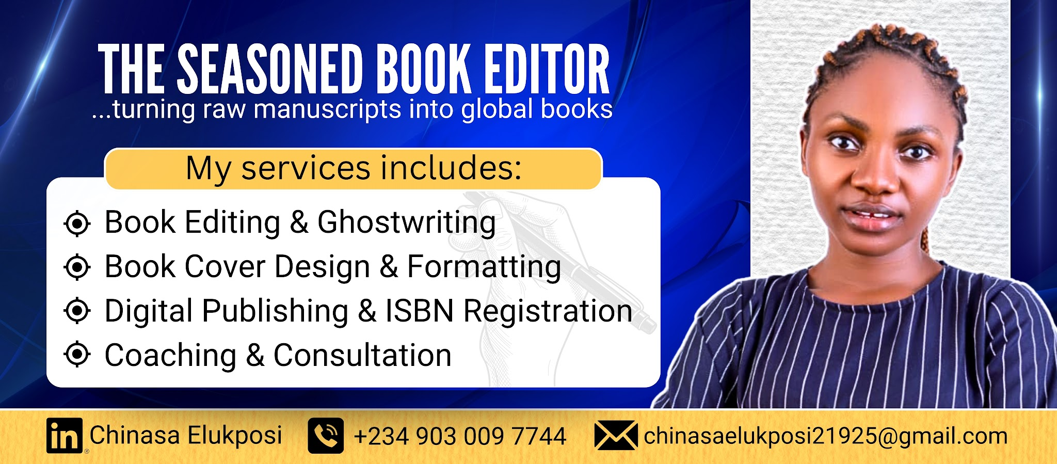

MY RATE

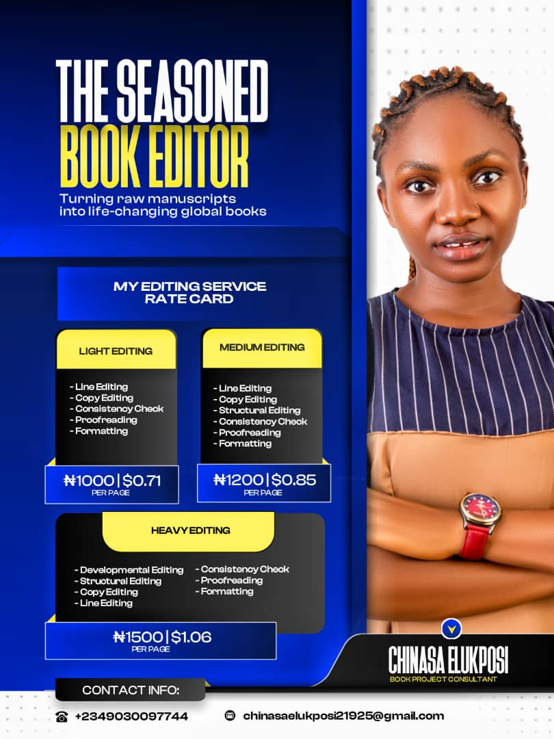

She charges NGN 1,000 per page for non- fiction manuscripts.

She charges NGN 1,500 per page for fiction manuscripts.

However, the quality of the manuscript, niche, page count, and time frame can cause slight changes.

Feel free to reach out to her through the following channels.

WhatsApp: +2349030097744
Email: chinasaelukposi21925@gmail.com
Facebook/LinkedIn: Chinasa Elukposi

She looks forward to delivering her best services to you.

Thank you.

